🛍️Creeds Shopy🛍️

Shopify Internship Project Documentation

Internship Role: Software Analyst (eCommerce)

Platform: Shopify

Project: Complete eCommerce Website Setup & Launch

Store Name: Creeds Shopy

URL: <https://admin.shopify.com/store/zfws4h-9a>

Theme Used: Trade (Free)

Date: June 2025

Submitted by:

Venkateshwaran T

Email: tvenkateshwaran14@gmail.com

Phone: +91-9940300572

LinkedIn: https://www.linkedin.com/in/venkateshwaran14

# 1. Project Overview

The Creeds Shopy project was developed as part of a Software Analyst (eCommerce) Internship. This internship project required the end-to-end setup of an eCommerce website using Shopify, one of the world’s leading online store platforms. The objective was to simulate a real-world eCommerce scenario including product listing, storefront customization, marketing email setup, and final documentation.  
  
The goals of this project were to:

* Understand the basic structure and operations of an online store
* Gain experience in UI/UX customization using no-code Shopify tools
* Implement product SEO techniques
* Create a launch email campaign using Shopify Email
* Document and present all work done in a professional manner

# 2. Store Details

• Store Name: Creeds Shopy

• Platform: Shopify (Free Trial used)

• Theme Used: Trade (responsive, minimal, user-friendly)

• Store Type: Lifestyle & Fashion Accessories (T-Shirts & Mugs)

• Target Audience: Young adults and professionals (18–35 years)

# 3. Product Listing

|  |  |  |  |  |
| --- | --- | --- | --- | --- |
| Product Name | Variants | Price | SEO Title | SEO Meta Description |
| Cotton Graphic T-Shirt | Size: S, M, L; Color: Black, White | ₹699 | Buy Graphic Cotton T-Shirts Online | Stylish breathable cotton t-shirts available in multiple sizes and colors. |
| Motivational Quote Mug | Quote: Rise & Grind; Color: White, Blue | ₹299 | Buy Quote Mugs – Ceramic 350ml | Durable ceramic mugs with positive quotes – perfect for daily motivation. |

Two distinct products were listed to showcase variety in SKUs. Each product was uploaded with title, high-resolution images, descriptions, pricing, and multiple variants (such as size, color, or design). Additionally, SEO title and meta description were added to increase visibility in search engines.

# 4. Theme Customization & Homepage Design

Using Shopify's 'Customize Theme' feature, the home page was professionally designed to reflect a clean, engaging, and modern aesthetic. A banner image was created using Canva to set the visual tone. Sections added:

* Hero Banner with CTA (Call-to-Action): 'Shop Now'
* Featured Products Section: Displaying both listed items
* Newsletter Signup Section: Encouraging users to subscribe
* About Us Section: Introducing Creeds Shopy and its vision
* Testimonials Section: Mock user reviews to build trust

Attention was given to user experience, clarity, and visual hierarchy. The homepage offers a professional look that can rival real eCommerce stores.

# 5. Email Marketing Campaign

To initiate customer engagement, an email campaign was created and launched using Shopify Email. A 10% discount was offered to first-time users through a custom discount code. Email details:

* Campaign Name: CreedsShopy_Launch10_Campaign_June2025
* Subject Line: 'Creeds Shopy is Live – Get 10% OFF!'
* Discount Code: VENKEY14 (applies store-wide)
* CTA: 'Shop Now' button linked to the product page
* Design: Used branded banner, concise messaging, and engaging language

The email followed eCommerce email best practices with clarity, urgency, and promotional value.

# 6. Screenshots to be Attached

To validate all steps performed, the following screenshots should be included in the final submission:

**Shopify Dashboard**

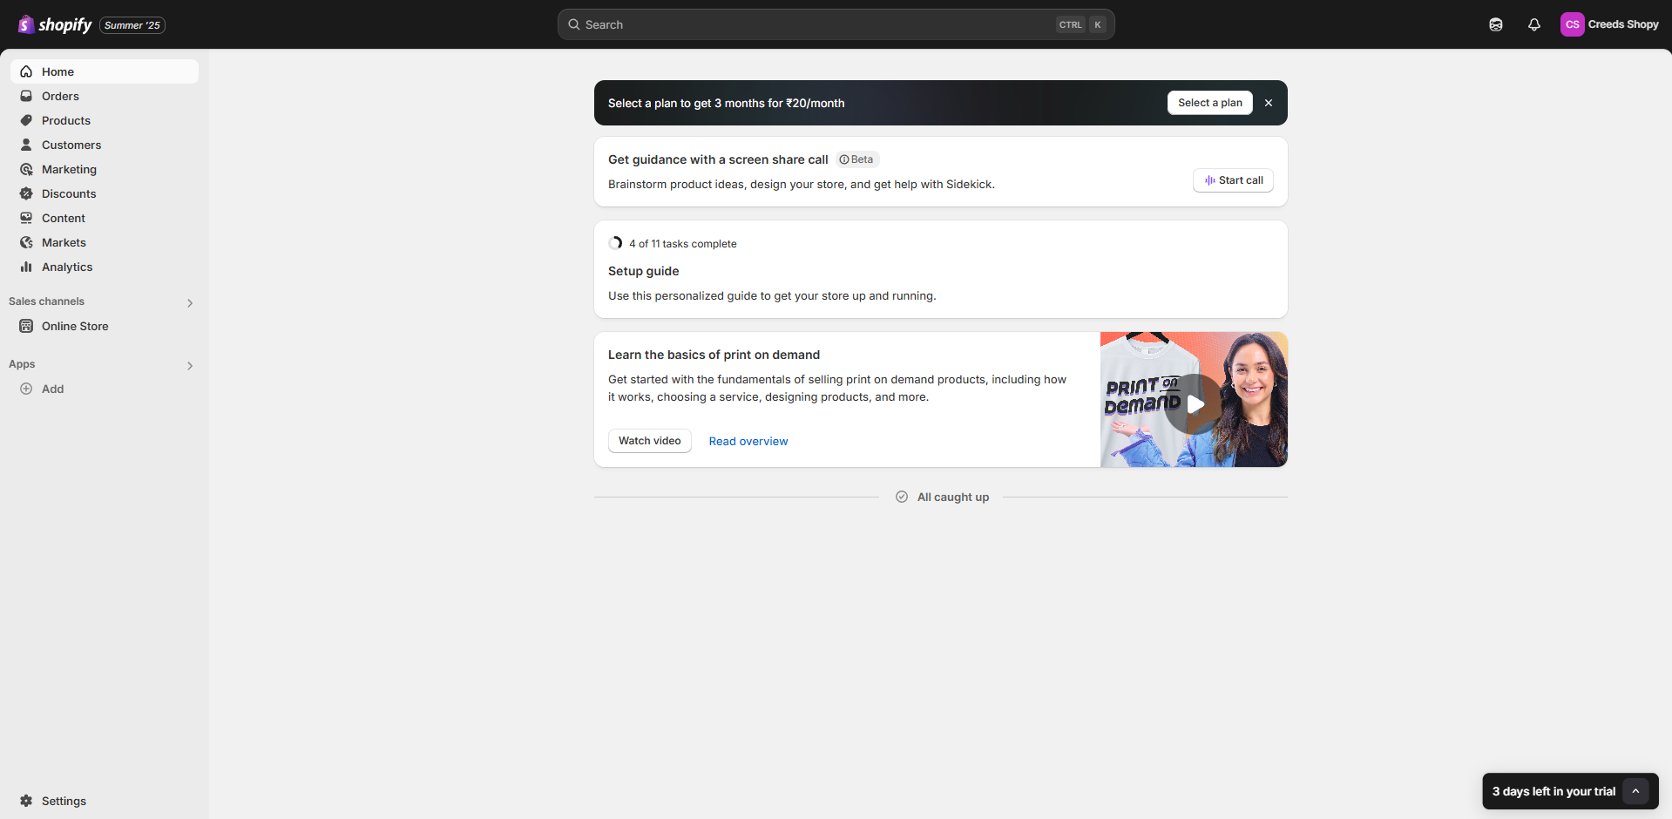

**Product Pages**

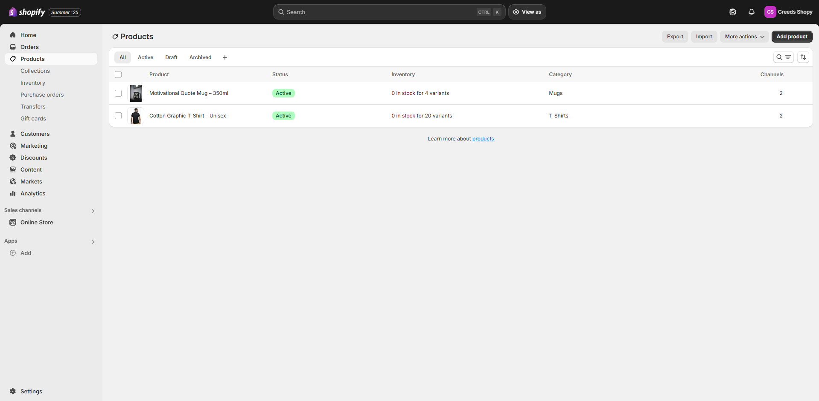

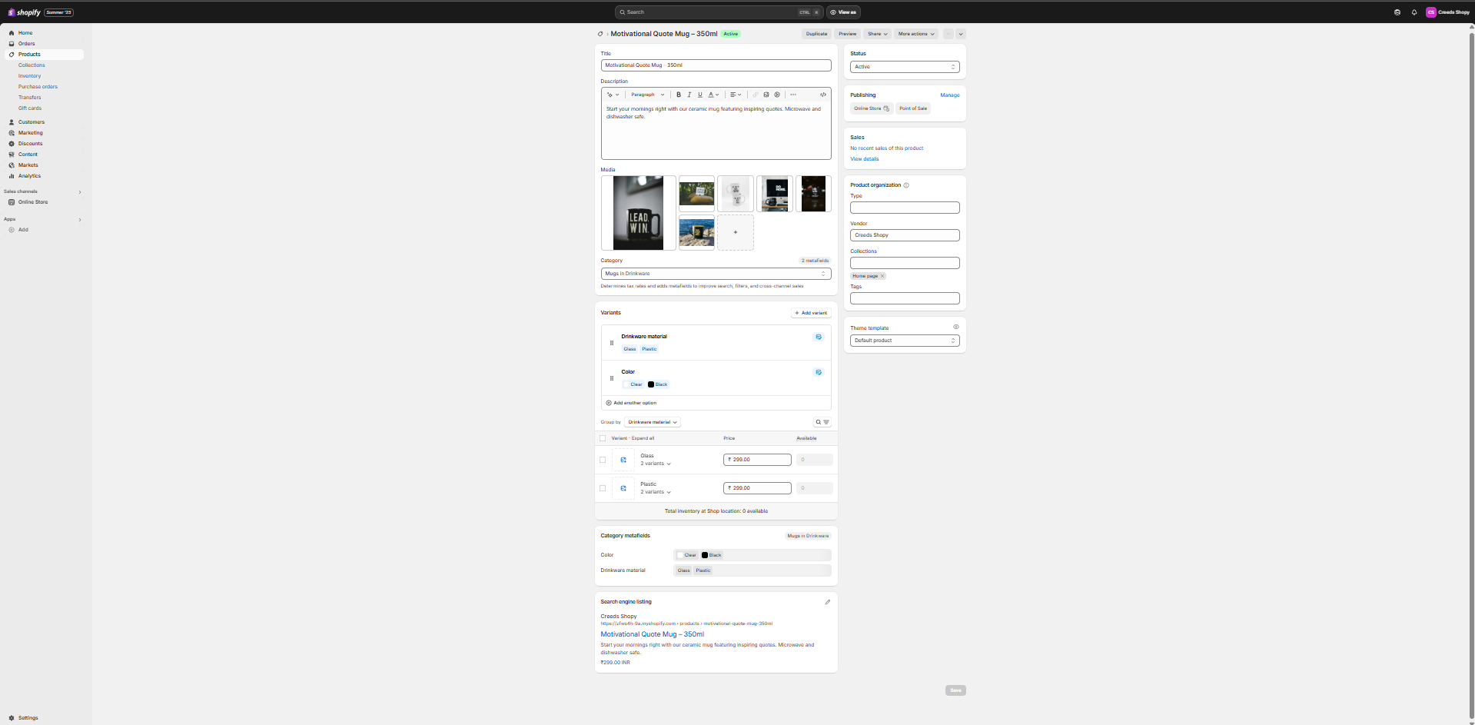

**Theme Editor / Home Page**

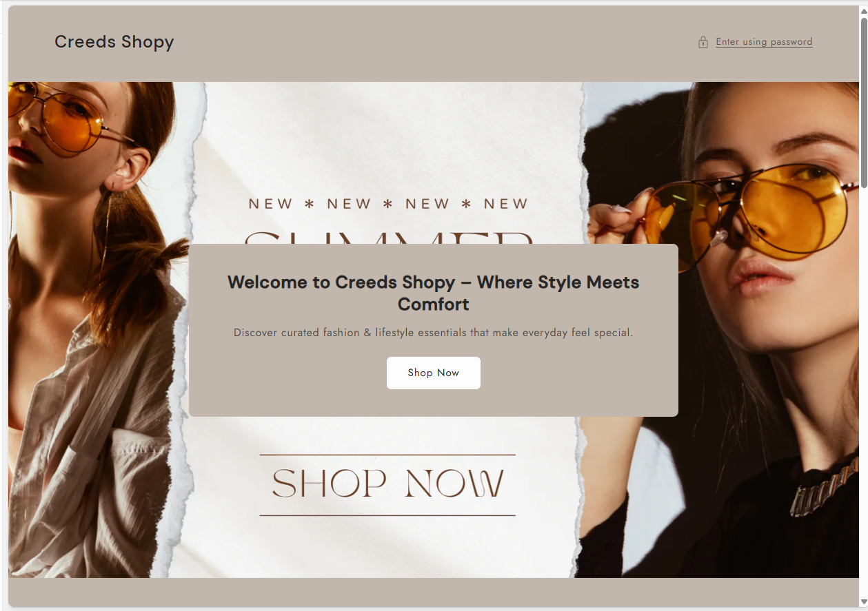

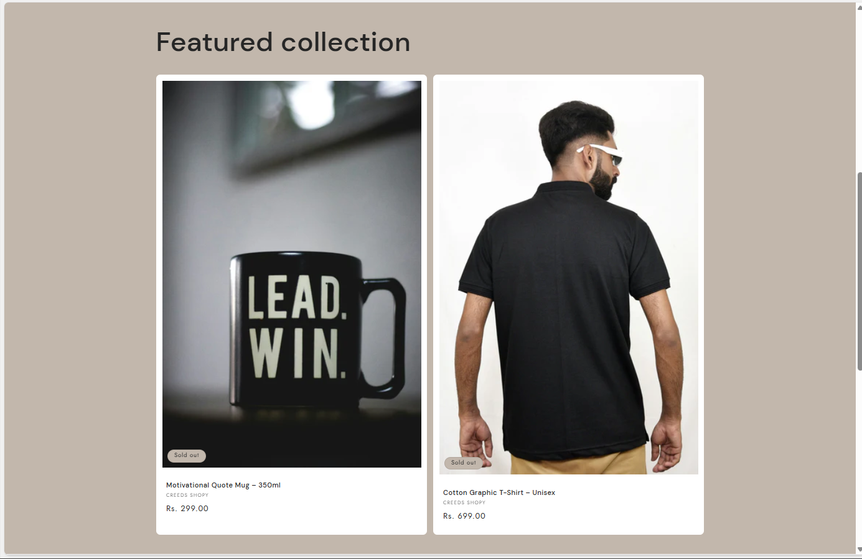

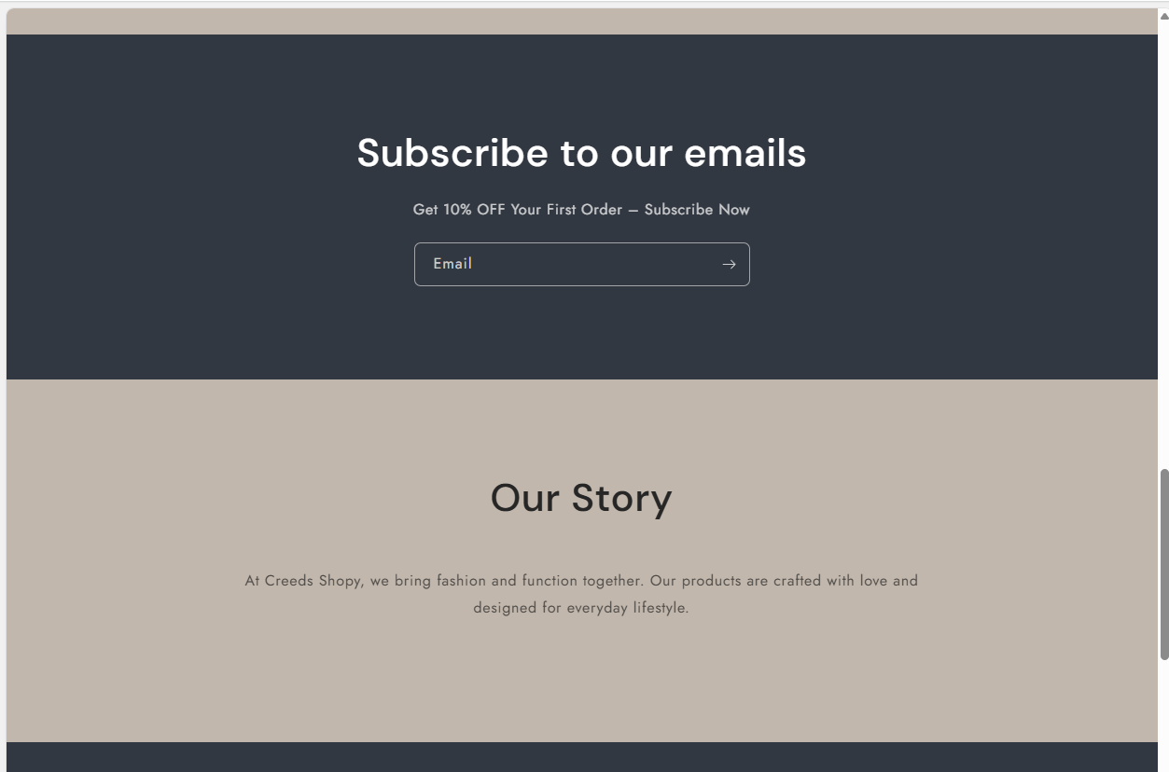

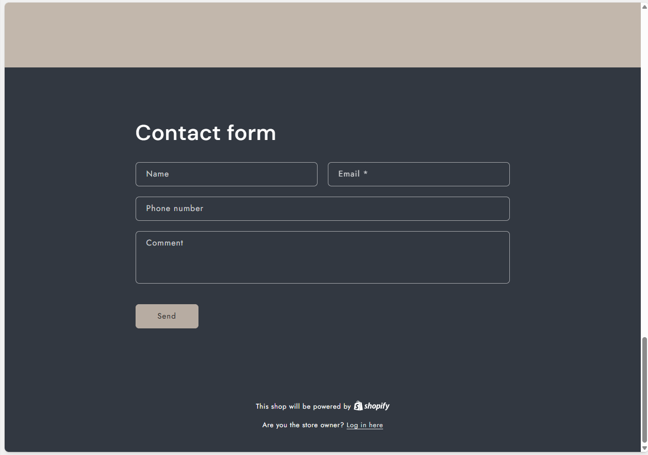

**Discount Code Settings**

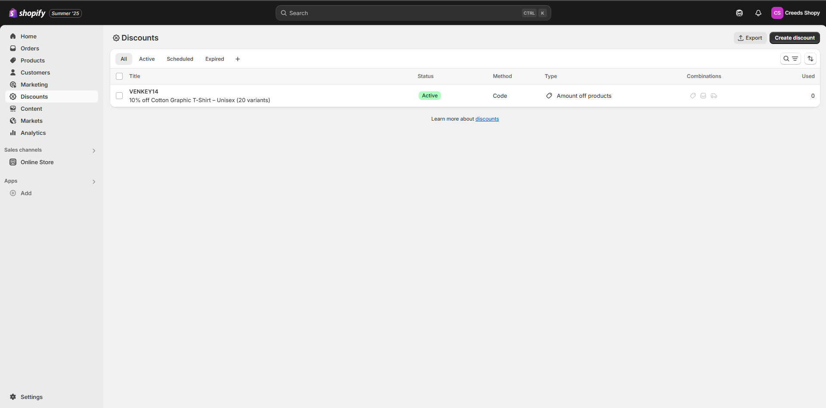

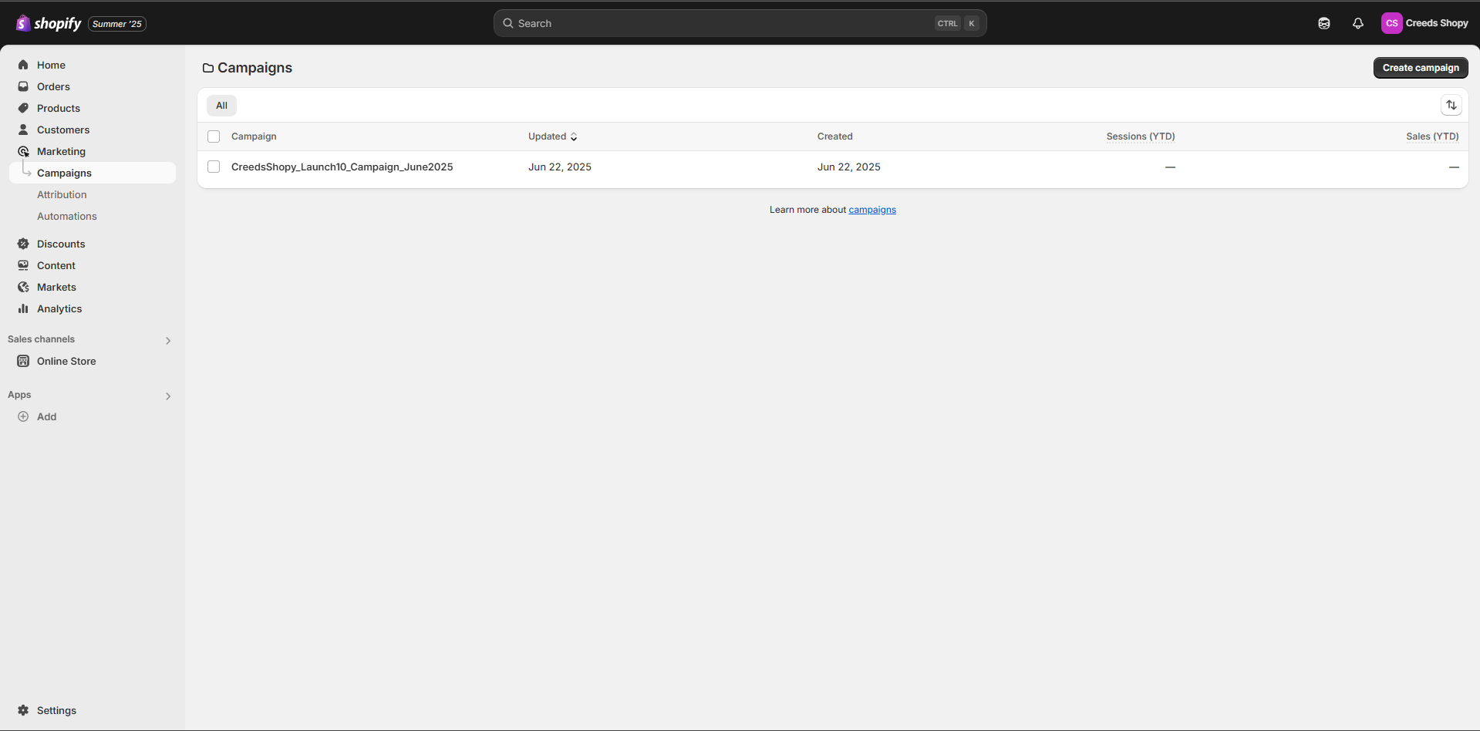**Email Campaign Editor and Preview**

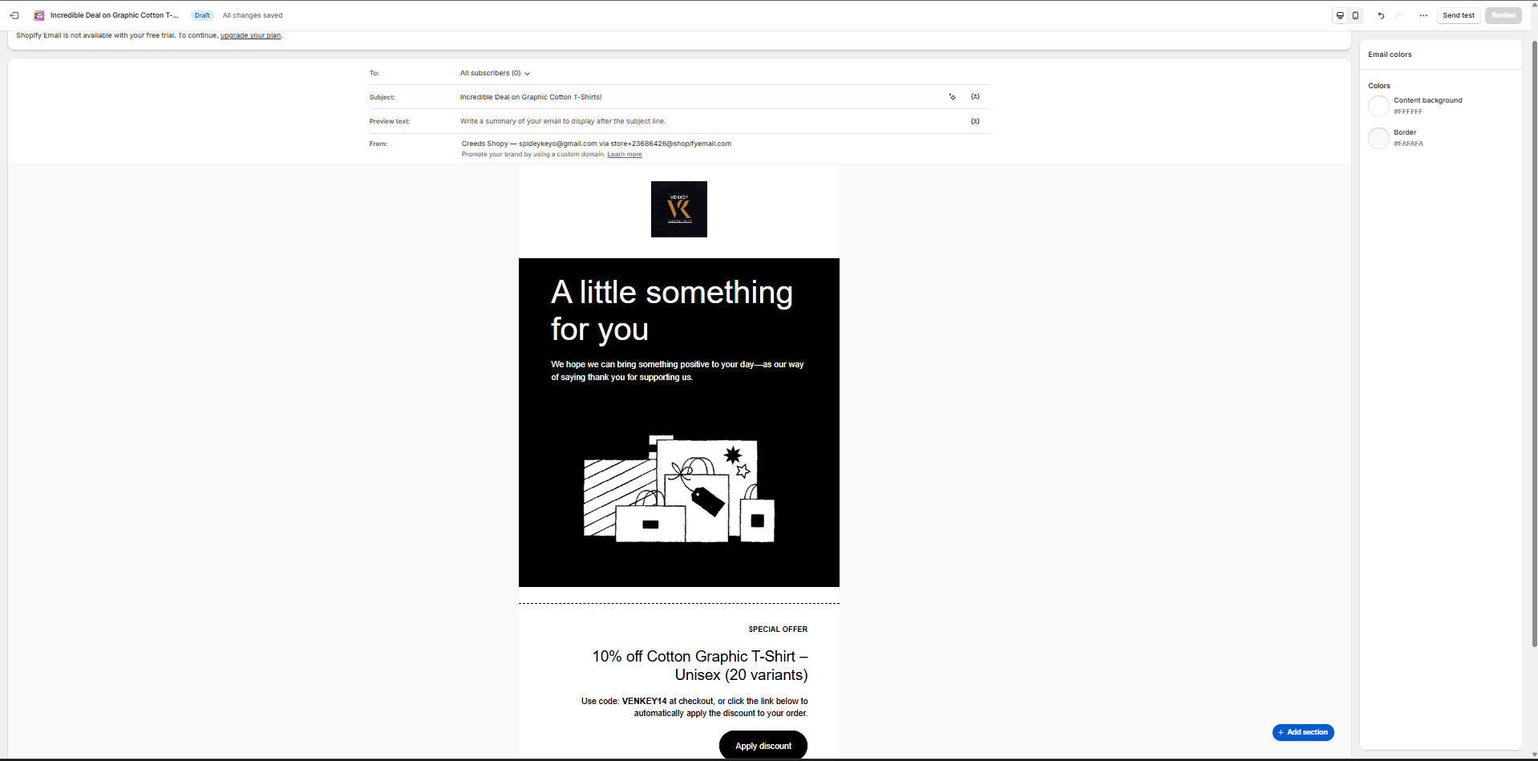

# 7. Conclusion & Learnings

This internship project successfully demonstrated the entire eCommerce store lifecycle using Shopify. From technical setup to marketing, each element contributed to building a functional and branded store. Key skills developed during this project include:

* eCommerce UI/UX configuration
* Product inventory setup and SEO tagging
* Email marketing strategy execution
* Shopify admin tools and campaign reporting

The project was completed within the required timeframe, with clean execution and documentation suitable for real-world applications.

— End of Report —

Prepared by:

Venkateshwaran T

Software Analyst (eCommerce) – Internship

Email: tvenkateshwaran14@gmail.com

LinkedIn: https://www.linkedin.com/in/venkateshwaran14